CREW360 All Star – Michael mitchell
The CREW360 Safety Steering Team recognizes Michael Mitchell as a CREW360 All Star. Michael first began working for Stacy Witbeck on February 27th of this year as a Foreperson on the Rapid Ride I project in Kent, Washington. However, Michael worked previously on Stacy Witbeck projects as a subcontractor employee including the R200 Downtown Redmond Link Extension project. After a few years working for SW as subcontractor employee, he joined our team and has been an excellent safety leader demonstrating why his safety leadership fits well in his role as a Foreperson. Michael leads by example and he has also become a local hero – more details on his heroism to follow – but before you get there, here is what others are saying about Michael and his perspective on why working safe matters.

What others say about Michael:

“Not all heroes wear capes; sometimes they wear safety vests & steel toe boots. Michael has not only stepped into the leadership position as our Traffic Control Supervisor but has been a great addition to the team and has made it his mission to maintain a safe working environment for not only his colleagues, but really anyone in the general vicinity around him. Recently he performed CPR on a pedestrian until EMS showed up and prior to that received a letter of recognition from local law enforcement agency after jumping into action with helping direct morning rush hour traffic around a threatening scenario involving an individual having a mental health crisis in the middle of the road.”
– Joe Grijalva, SW Traffic Manager

Now a Q and A with Michael:

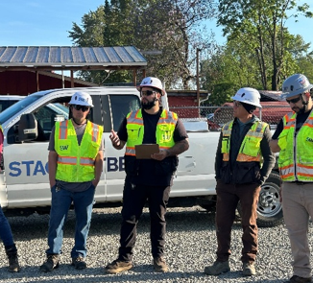
Why do you work safely?
- I work safely because I have a girlfriend and a 5-year-old son waiting for me at home, but I also work safely because I care about the people I work with. Every person on my crew has someone waiting for them too. If I can help create an environment where everyone goes home safe every day, then I’ve done my job.

What does safety mean to you?
- Safety is about taking care of one another. It’s building a culture where everyone feels comfortable speaking up, asking questions, and looking out for each other. When people know you’ve got their back, everyone works better together.

How do you promote safety?
- I believe the best way to promote safety is to lead by example. As a supervisor, I know people are always watching how I handle situations. I hold myself to a high standard, encourage open communication, and make it a priority to coach my team – not

just on how to do the job, but why we do it safely. If I can help someone become a better, safer employee, that’s a win for all of us.

What is something you learned that you still teach others?
- The biggest lesson I’ve learned is that leadership isn’t about having all the answers – it’s about setting the example. I remind my team that there’s no shame in asking questions, taking your time, or speaking up if something doesn’t seem right. The goal isn’t just to finish the job, it’s to finish it the right way and make sure everyone goes home safely.

What has been your most memorable moment at work?
- The most memorable moments have been watching people grow. Seeing someone gain confidence, develop new skills, and take pride in their work is one of the most rewarding parts of being a supervisor. Watching a team come together to overcome challenges and succeed is something I’ll always remember.

What SW project was your favorite?
- It’s honestly a tie between the Redmond Light Rail project and my current Rapid Ride project. Redmond was one of those jobs where it was simply fun to come to work every day. The people
made it a great experience, and we built some lifelong friendships. My current Rapid Ride project has been just as rewarding, but for different reasons. I enjoy the challenges that come with leading a team of 11 employees and helping them develop. Watching them grow, build confidence, and push themselves to be better has made this one of the most fulfilling projects of my career.

What SW role was your favorite?
- My current role as a supervisor has been my favorite. It gives me the opportunity to lead by example while helping others grow. I enjoy mentoring my team, solving problems together, and creating an environment where people feel supported and challenged to be their best. Seeing my employees succeed is one of the most rewarding parts of the job.

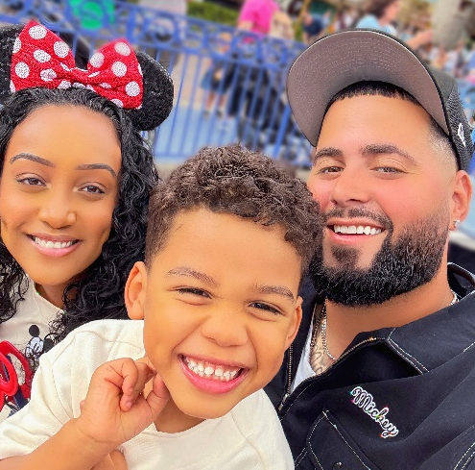
Where did you grow up?
- I was born in California and lived there until I was seven before moving to Brooklyn, New York. At 15, I moved to Seattle, where I’ve been ever since. Growing up in different parts of the country has given me an appreciation for different people and perspectives, and Seattle has become home.

What do you do for fun?
- My favorite thing to do is spend time with my girlfriend and my 5-year-old son. Whether we’re out exploring, relaxing at home, or just making memories together, that’s what means the most to me. I also enjoy gaming, watching sports, and taking on projects around the house.

More amazing things Michael has done!

On the morning of August 5th, Michael called 911 for a person from the general public who he witnessed go from a distressing situation to falling over and then became unconscious and not breathing near the Rapid Ride project. With guidance from EMS dispatch, he performed full compression CPR until EMS arrived and took over. Ultimately, after additional use of Narcan and EMS personnel aid, the person started breathing and regained consciousness. EMS confirmed that Michael’s quick action as a Good Samaritan saved this person’s life.
